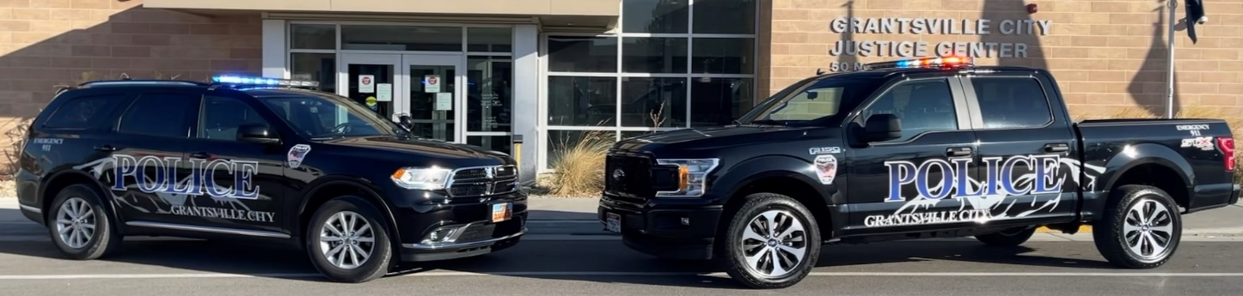
We’re hiring! Join our Team!
Grantsville City is looking to establish a hiring roster that will be used to fill current and future positions within the Police Department. Law enforcement is an essential, demanding, and yet rewarding profession that offers a steady income and great benefits. Agencies across the State are struggling to fill vacancies in their Departments. On the bright side, the shortage of qualified applicants is driving wages up for the profession. Law enforcement as a career offers the satisfaction of making a difference in the lives of others as we serve our communities, safeguard lives and property, protect the innocent against deception, the weak against oppression or intimidation and the peaceful against violence or disorder. Applications can be accessed using the link at the bottom of the page or by visiting the Grantsville City Police Department. Please send completed applications to police@grantsvilleut.gov or 50 N. Bowery Street, Grantsville, UT 84029.

WWW.grantsvilleut.gov/gcc/employment/
ADA/EEO Employer
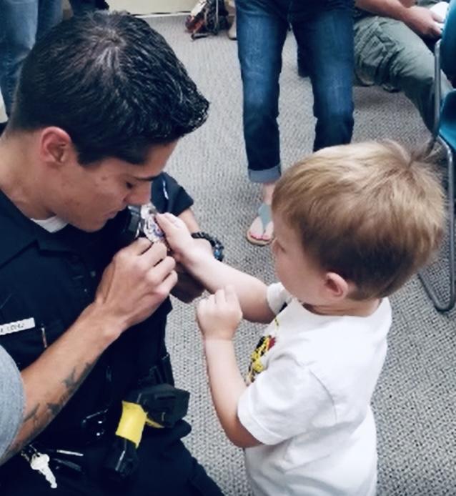
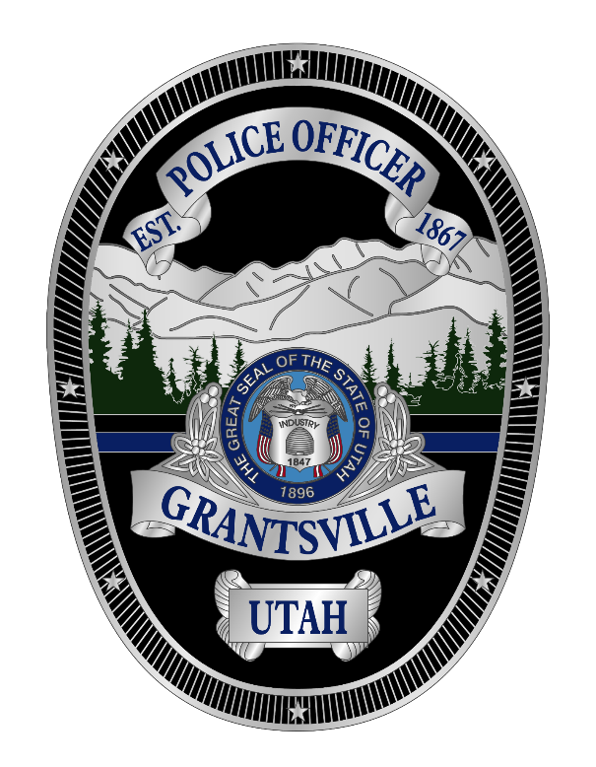
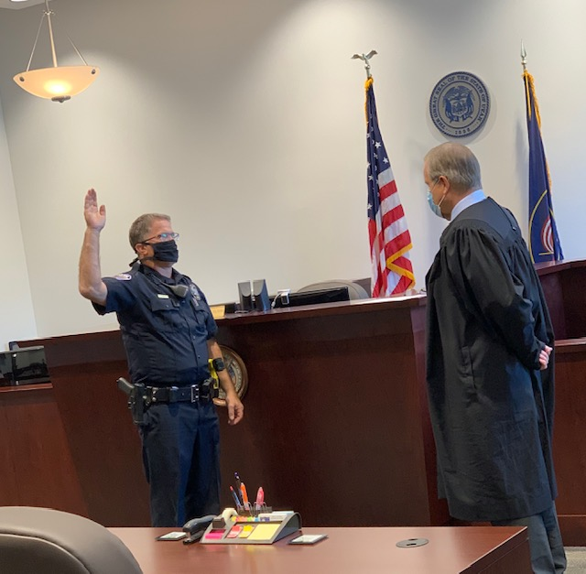
HIRING PROCESS
Applications - All applications must be filled out correctly and include the required attachments.
Panel interview and written test
Non-certified applicants may be asked to complete a physical fitness test.
Full background investigation
Psychological and medical examination
Drug test
Interview with the Chief of Police

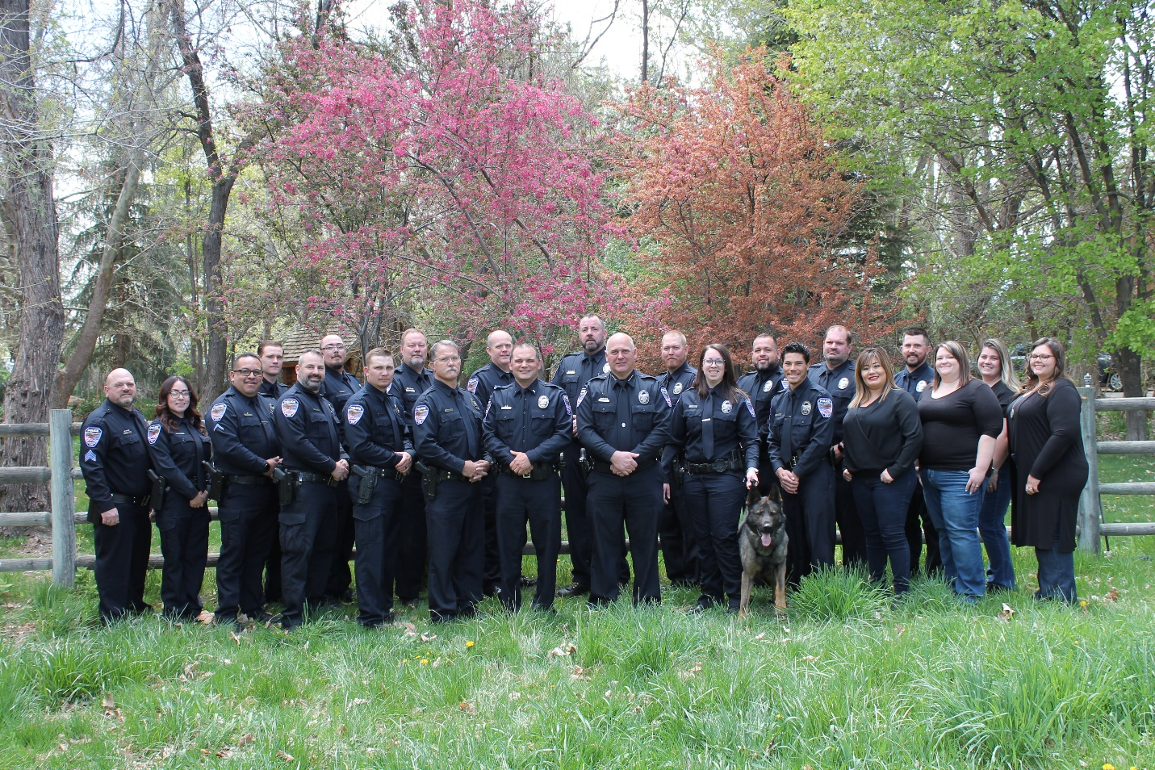
The Grantsville City Police Department

Due to the projected growth in the area we expect our 20-officer Department to rapidly increase in size creating many early opportunities to promote and advance your career. We offer opportunities to specialize including SWAT, Honor Guard, Crisis Negotiation, CVSA, Tooele County Major Crimes Task Force, Investigations, ICAC, EMT, School Resource Officer, PIO, DRE, and K-9. We train all of our officers to be part of the Crisis Intervention Team. We encourage lateral transfers and one-year retirees seeking a second law enforcement career and offer higher wages for experienced officers. Though we are getting busier, patrol call load is manageable and ideal for police officers who wish to be proactive in traffic and drug enforcement. Our patrol officers work four 10-hour shifts and rotate between day and grave shifts. For safety, Chief mandates that we always have at least 2 officers on duty at all times. Patrol officers are issued a take home vehicle and a body worn camera. Our base of operations is the new Grantsville City Justice Center dedicated in January of 2018.

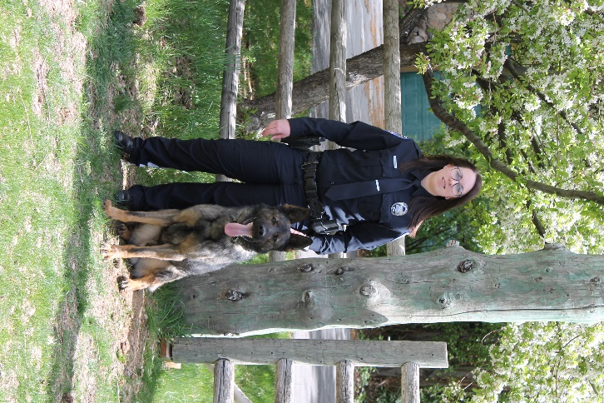
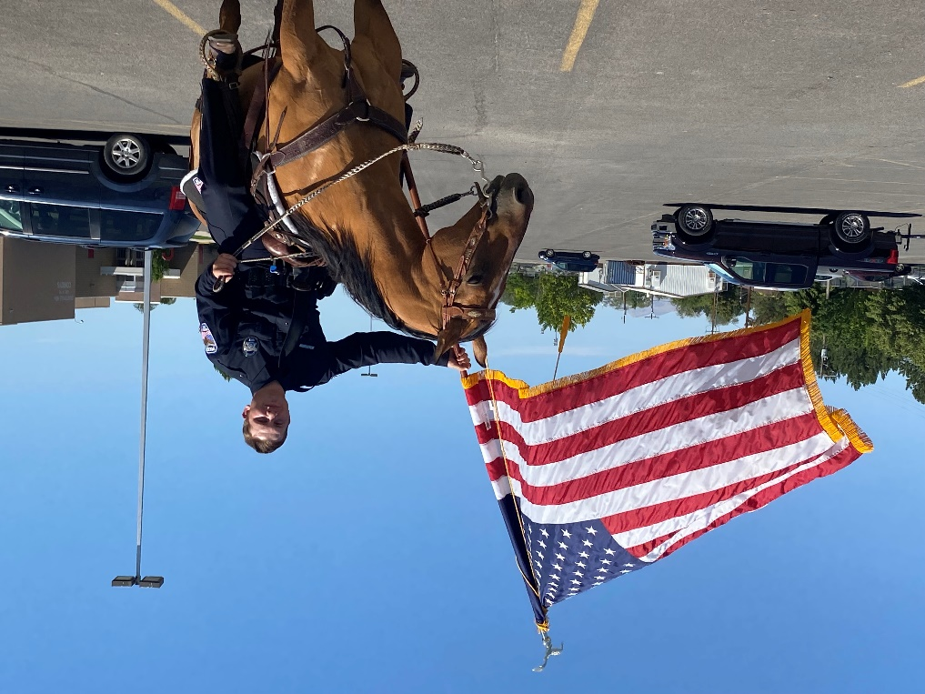

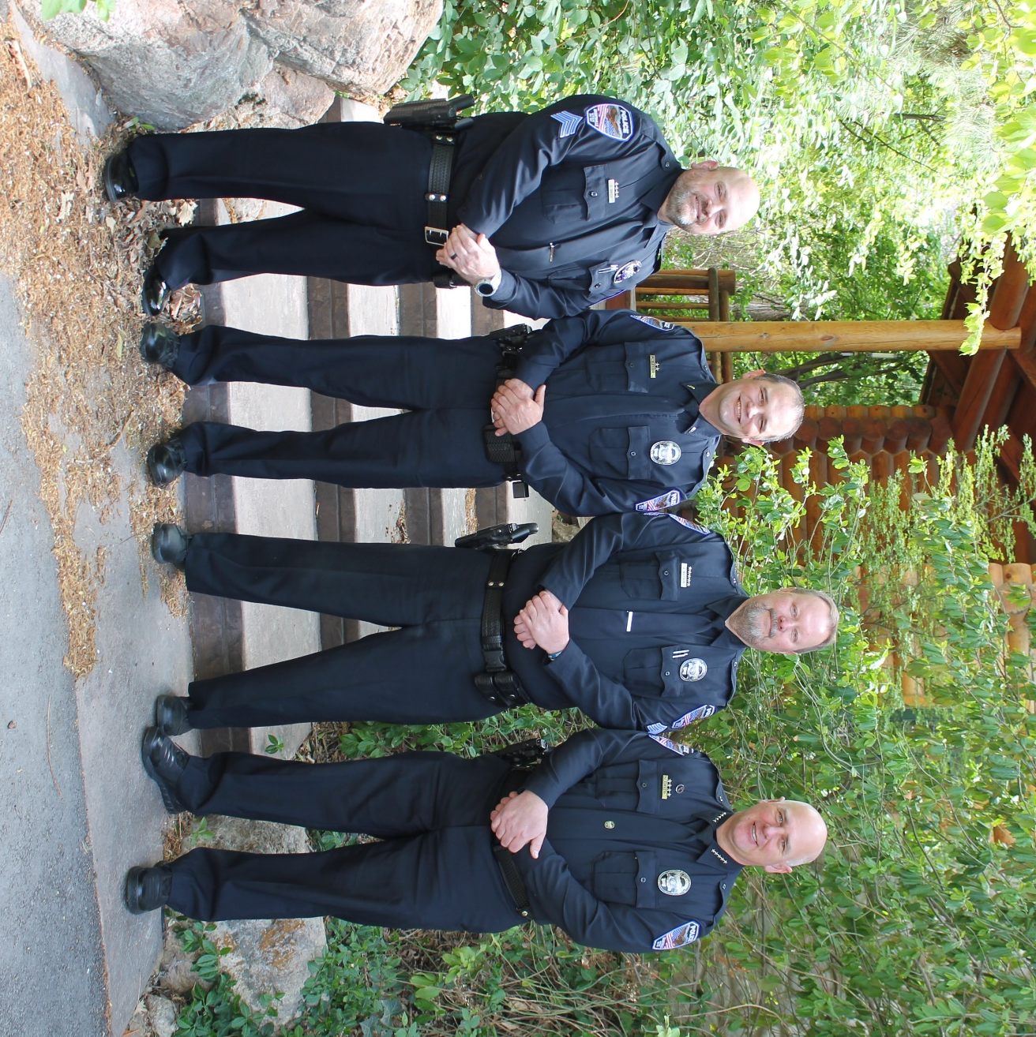
ADMINISTRATION
Chief – Jacob Enslen
Lieutenant – Robert Sager
Investigations Sergeant - David Greco
Patrol Sergeant – Jeff Watson

About Grantsville City
Grantsville City is a family-oriented community that enjoys a rural lifestyle just 30 minutes west of Salt Lake City. A rapidly growing population of approximately 14,000 people call Grantsville home. Grantsville is booming with new housing and annexation requests. Some projections show that the city could double in size in five years. Many are attracted to Grantsville’s ideal combination of a hospitable, country feel and its proximity to a big city. You still have the conveniences of the big city but can quickly escape to fresher air and an area better suited to raise a family. Grantsville boasts a plethora of horse and UTV trails and picturesque views of the Stansbury Mountains and the Great Salt Lake. Grantsville is home to the Utah MotorSports Campus, the host venue for events such as Nitro Circus, NASCAR, and Night Lights. Country Fan Fest is held here every summer at the Deseret Peak Complex. The J. Reuben Clark Farm hosts an annual Honey Festival, petting zoo, and other fun activities. Our patriotic community celebrates the 4th of July for an entire week with sport competitions, parades, car shows, fireworks, and more.
Though some commute to Salt Lake City for employment, the Grantsville area is primed for economic opportunity. The commercial landscape is rapidly changing and promises to provide many job opportunities. The Romney Group broke ground north of the Purple Mattress Warehouse on December 3, 2020, for the Lakeview Business Park, a 1900-acre light industrial manufacturing area. A new I-80 exit, the Mid-Valley Highway, makes the area more attractive for future commercial business and expedites commutes to and from the valley.

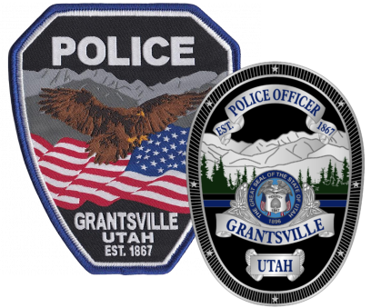
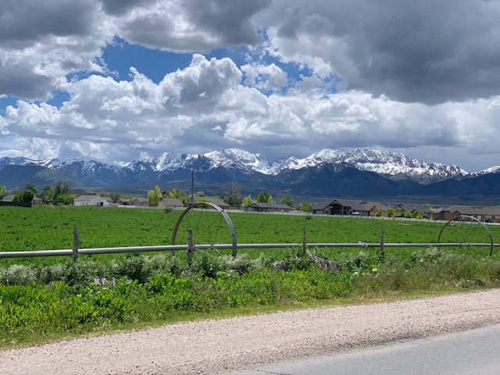

Pay and Benefits
Starting wage is 26.00/hour with a 3% increase after successful completion of a 6-month probationary period.

Wages for laterals is negotiable based on credit for years of experience, education, and trainings. Special Function Officers may receive credit at a lower rate.

The City recognizes the current ever-increasing market value of a quality police officer and strives to keep our wages competitive with neighboring agencies.

Salary Schedule
80 hour PP
- Health Plan Options
- Dental
- Vision
- Take home vehicle
- Tuition reimbursement
- Line of duty life insurance
- Dependent and supplemental life insurance
- Flexible Spending Accounts
- Health Savings Accounts
- Short-term disability
- Long-term disability
- Utah State Retirement
- EAP Program
- 3% match 401k Contribution
- Paid vacation and sick time
- Paid holidays
- Overtime Opportunities
- Uniform Allowance
- Free car washes
BeNEFITS

